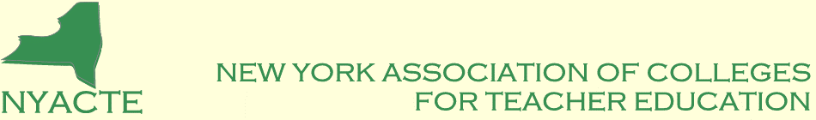

Institutional Membership Dues Invoice
FY 2022-2023 (September 1, 2022 - August 31, 2023)

Institution: ______________________________________________________________

Contact Person/Title: ______________________________________________________

________________________________________________________________________

Address: ________________________________________________________________

_______________________________________________________________________

________________________________________________________________________

Phone: _______________________________ Fax: _____________________________

E-Mail: _________________________________________________________________

Please send this form and a check for $275.00 payable to “NYACTE” to:

Patrick Ianniello, Ph.D. – NYACTE Treasurer
Director, Master of Science in Education Program
Metropolitan College of New York
60 West Street
New York, NY 10006

E-Mail Address – pianniello@mcny.edu

Tax Exempt Numbers - Federal: 20-3309208; New York: 244519

OFFICE USE ONLY – DO NOT FILL-IN BELOW THIS LINE
_____________________________________________________________________

Amount Received______________________________Date_____________________________

Check #________________________________________________________________

